**Step 1:**

- Enable your 2 step verification

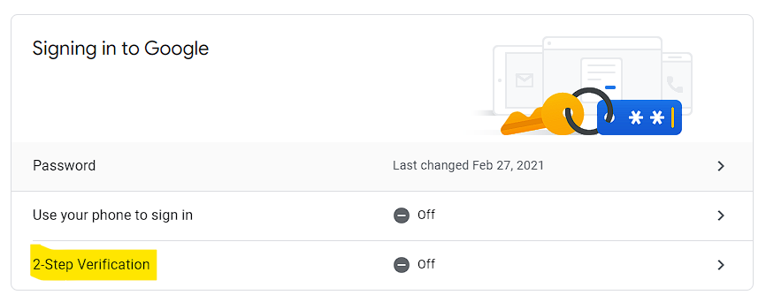

**Step 2:**

- Once you've done step 1, you should now have access to app passwords

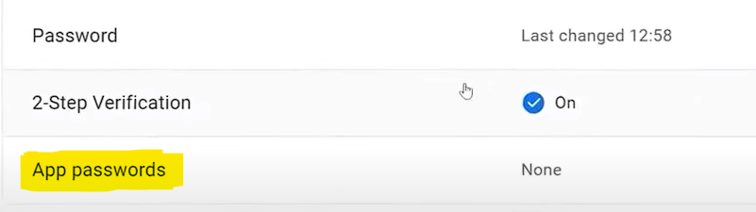

From there:

- select other (custom name)

- set a name for your app (whatever name you want)

- Then click generate

You should now see the password generated like this:

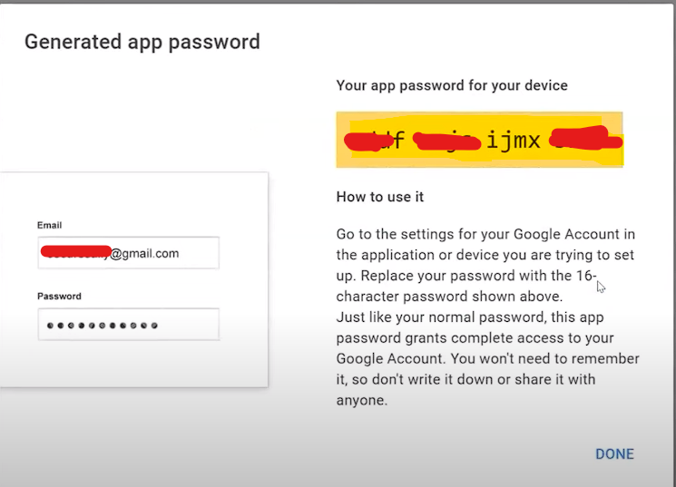

Copy this and replace your password in your code with this new generated password.

You should now be able to send an email without error.